**HAPPY TAILS HAVEN APP USER GUIDE**

LOGIN BUTTON FOR EXISTING USERS TO LOGIN INTO A NEW DEVICE WITH THE SAME ACCOUNT

SIGN UP BUTTON FOR NEW USER SO THEY COULD REGISTER A NEW ACCOUNT

**HOMEPAGE**

KEY IN YOUR PASSWORD OF YOUR ACCOUNT

WHEN FORGETTEN YOUR PASSWORD, PRESS THIS TO RECEIVE A ONE TIME PIN

INSERT EMAIL ADDRESS OF YOUR ACCOUNT

PRESS BUTTON TO LOGIN

**LOG IN PAGE**

LIST IN YOUR EMAIL

RE-TYPE YOUR PASSWORD TO CONFIRM IT

INSERT YOUR FULL NAME AS PER IN IC

LIST IN YOUR DESIRED PASSWORD

PRESS THIS BUTTON TO SIGN UP FOR A NEW ACCOUNT

**SIGN UP PAGE**

SORT BY THE GIVEN FILTERS SUCH AS LATEST

ADD TO FAVOURITES BUTTON ALLOWS YOU TO BOOKMARK THE PETS TO VIEW LATER

OPEN OF CLOSES THE NOTIFICATION FOR NEW UPDATES OR REMINDERS

CHOOSE YOUR DESIRED FEED BY SELECTING THE TYPE OF ANIMALS YOU WANT

ABLE TO SEARCH WITH SOME KEYWORDS



**PET ADOPTION PAGE**

COULD BE USED TO PERSONALISE THE USER’S PROFILE

COULD HELP USERS MANAGE THE NOTIFICATION SETTINGS

COULD HELP GET IN CONTACT WITH THE HELP DESK

SHOWS THE USERS NAME AND PROFILE PIC

SHOWS THE COMPANY’S MISSION AND HISTORY

GOES TO SETTINGS SO THE USERS COULD SET THE APP TO THEIR LIKING

LOGS OUT THE ACCOUNT FROM THE DEVICE

**DROP-DOWN MENU**

SHOWS 5 MENU BUTTONS TO QUICKLY GO BETWEEN PAGES

BLOGS WHICH SHOW THE SUMMARY AND USER WHO POSTED IT, WHILE ALSO GIVING AN OPTION TO SAVE AND SHARE THE BLOG

**BLOGSPOT PAGE**

EVENT SCHEDULE CALENDAR IS ALSO A FEATURE WHICH ALLOWS USER TO VIEW UPCOMING OR PREVIOUS EVENTS HELD BY HAPPY TAILS HAVEN

THE EXPLORE PAGE ALLOWS US TO DISCOVER NEW EVENTS BASED ON OUR PREFERENCES WITH THE VIEW ALL BUTTON ABLE TO SHOW ALL THE EVENTS AVAILABLE



ALLOWS THE USER TO EITHER VIEW THE JOB AND SEE ITS DETAILS AND JOIN THE EVENTS



ALLOWS TO SEARCH EVENTS WHILE ALSO FILTERING IT ACCORDING TO THE PREFERENCE

**EVENTS PAGE**

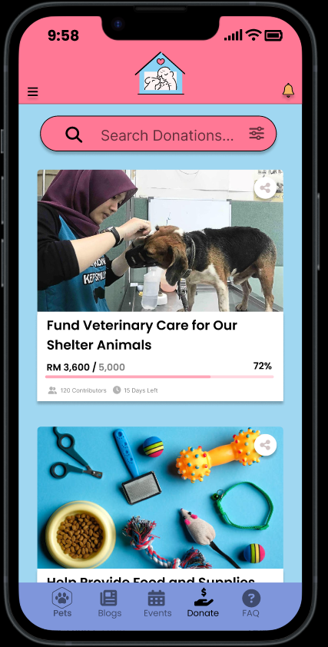

SEARCH UP VARIOUS DONATIONS

SHARE BUTTON TO SHARE THE LINK OF DONATION TO OTHER PEOPLE

SHOWS THE DONATION NAME AND DETAILS SUCH AS HOW MUCH MONEY IS COLLECTED

**DONATION PAGE**

THE BUTTON IS FOR USERS TO CONFIRM THE FUND THEYRE DONATING TO AND BRINGS THEM TO ANOTHER PAGE

**DONATION PAGE**

KEY IN YOUR DESIRED AMOUNT FOR DONATION

ALLOWS THE USER TO CHOOSE THE DONATION AMOUNT WHICH THEY PREFER WHETHER IT’S A PRESET OR YOUR PERSONALISED ONE AND ALLOW THEM VARIOUS PAYMENT METHODS

**DONATION PAGE**

LIVE CHAT BUTTON TO TALK WITH AN AGENT TO GET MORE INFORMATION ABOUT ANY QUESTIONS THEY USERS MAY HAVE

SHOWS THE MOST ASKED QUESTIONS SO USER COULD GET A QUICK ANSWER

ALLOWS THE USER TO SEARCH FREQUENTLY ASK QUESTIONS

**FAQ PAGE**